T.C.

ISTANBUL AYDIN UNIVERSITY INSTITUTE OF GRADUATE STUDIES
EDUVİSE:AN AI-POWERED ADAPTIVE LEARNING PLATFORM
BERKAY BİNİCİ (B2180.060056)
MUSTAFA BUĞRA BOZ (B2180.060028 )
Department of Software Development
Graduation project Program (English)

Thesis Advisor: Prof. Dr. Ali OKATAN

EDUVISE: AN AI-POWERED ADAPTIVE LEARNING PLATFORM
ABSTRACT
Traditional educational systems generally follow a fixed and standardized learning structure that fails to address the individual needs, learning speeds, and knowledge gaps of students. Modern learners require adaptive educational systems capable of personalizing learning experiences according to their academic performance, engagement level, and conceptual understanding.
This graduation project presents EduVise, an AI-powered adaptive learning platform designed to provide personalized educational experiences using modern web technologies, intelligent recommendation systems, and Large Language Model (LLM) integration. The platform dynamically analyzes student performance through diagnostic and formative assessments and generates individualized learning roadmaps tailored to each learner’s knowledge state.
The frontend architecture of EduVise was implemented using React.js and Vite, while Tailwind CSS and Zustand were utilized for responsive interface design and scalable state management. The backend infrastructure was developed using Python, FastAPI, and SQLAlchemy. The system uses SQLite as a unified relational database architecture for simplified deployment and portability.
Unlike traditional intelligent tutoring systems that rely on rule-based recommendation mechanisms or classical machine learning models, EduVise integrates Large Language Models through Anthropic API services. This architecture enables advanced contextual educational assistance, AI-generated counseling reports, adaptive recommendations, and dynamic learning guidance.
The platform additionally includes advanced modern educational modules such as gamification systems, discussion forums, notification infrastructure, and payment management systems. These modules transform the platform from a simple learning management system into a collaborative and interactive educational ecosystem.
The project demonstrates that modern AI-driven adaptive learning systems can significantly improve learning efficiency, engagement, personalization, and learner motivation while providing scalable and maintainable software architecture for future educational technologies.
Keywords: Adaptive Learning, Artificial Intelligence, Large Language Models, Personalized Learning, Educational Technology, FastAPI, React.js, Learning Analytics, Gamification, Intelligent Tutoring Systems
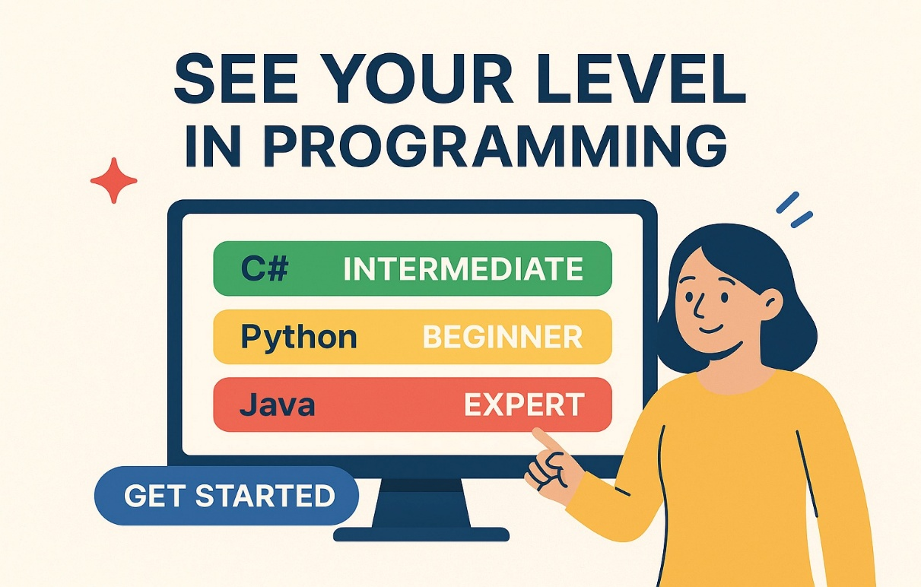
EDUVISE: YAPAY ZEKA DESTEKLİ UYARLAMALI BİR ÖĞRENME PLATFORMU
ÖZET
Geleneksel eğitim sistemleri genellikle öğrencilerin bireysel ihtiyaçlarını, öğrenme hızlarını ve bilgi eksikliklerini dikkate almayan sabit ve standartlaştırılmış öğrenme yapıları sunmaktadır. Modern öğrenme ortamlarında öğrenciler, akademik performanslarına, öğrenme düzeylerine ve etkileşimlerine göre kişiselleştirilmiş eğitim deneyimlerine ihtiyaç duymaktadır.
Bu bitirme projesi kapsamında geliştirilen EduVise, modern web teknolojileri, akıllı öneri sistemleri ve Büyük Dil Modelleri (LLM) entegrasyonu kullanarak kişiselleştirilmiş eğitim deneyimi sunmayı amaçlayan yapay zeka destekli uyarlanabilir bir öğrenme platformudur. Platform, öğrencilerin performanslarını diagnostik ve biçimlendirici değerlendirmeler aracılığıyla analiz ederek her öğrenci için özel öğrenme yol haritaları oluşturmaktadır.
EduVise platformunun istemci tarafı React.js ve Vite teknolojileri kullanılarak geliştirilmiştir. Arayüz tasarımı ve durum yönetimi için Tailwind CSS ve Zustand kullanılmıştır. Sunucu tarafı Python programlama dili ile FastAPI ve SQLAlchemy teknolojileri kullanılarak geliştirilmiştir. Sistem, taşınabilirlik ve kolay dağıtım amacıyla birleşik SQLite veritabanı mimarisi kullanmaktadır.
Geleneksel kural tabanlı yapay zeka sistemlerinden farklı olarak EduVise, Anthropic API entegrasyonu aracılığıyla Büyük Dil Modelleri kullanmaktadır. Bu yapı sayesinde sistem; bağlamsal eğitim desteği, yapay zeka destekli danışmanlık raporları, dinamik öneriler ve kişiselleştirilmiş öğrenme rehberliği sunabilmektedir.
Platform ayrıca oyunlaştırma sistemleri, forum altyapısı, bildirim sistemi ve ödeme yönetimi gibi modern modülleri de içermektedir. Bu modüller sayesinde sistem yalnızca bir öğrenme yönetim sistemi olmaktan çıkarak etkileşimli ve sosyal bir eğitim ekosistemine dönüşmektedir.
Bu proje, modern yapay zeka destekli uyarlanabilir öğrenme sistemlerinin öğrenme verimliliğini, öğrenci motivasyonunu, kişiselleştirmeyi ve kullanıcı etkileşimini önemli ölçüde artırabileceğini göstermektedir.
Anahtar Kelimeler: Uyarlanabilir Öğrenme, Yapay Zeka, Büyük Dil Modelleri, Kişiselleştirilmiş Öğrenme, Eğitim Teknolojileri, FastAPI, React.js, Öğrenme Analitiği, Oyunlaştırma, Akıllı Öğretim Sistemleri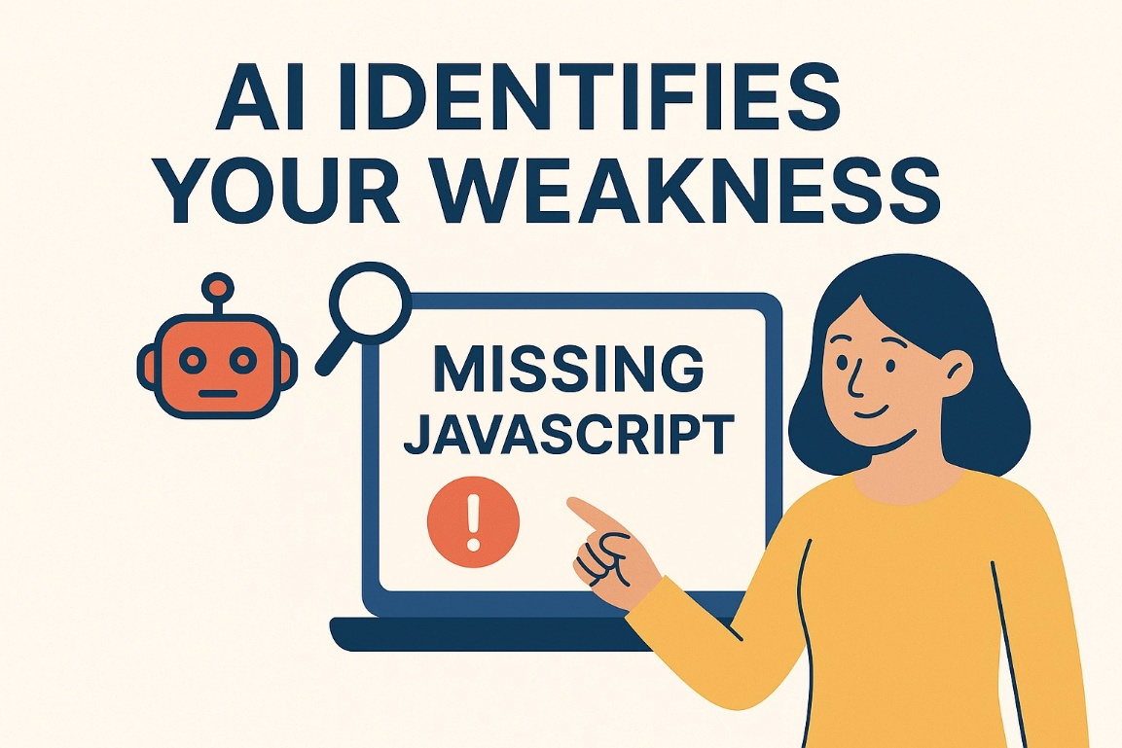

TABLE OF CONTENTS
DECLARATION ...... i
FOREWORD ...... ii
ABSTRACT ...... iii
ÖZET ...... v
TABLE OF CONTENTS ...... vii
ABBREVIATIONS ...... ix
LIST OF FIGURES ...... xi
LIST OF TABLES ...... xii
I. INTRODUCTION
1.1 Background and Motivation
1.2 Problem Statement
1.3 Project Objectives
1.4 Significance of the Project

II. LITERATURE REVIEW
2.1 Traditional E-Learning Platforms
2.2 Adaptive Learning Systems
2.3 Artificial Intelligence in Education
2.4 Large Language Models in Education
2.5 Gamification and Interactive Learning
2.6 Research Gap and Contribution

III. METHODOLOGY
3.1 System Architecture Overview
3.2 Course and Assessment Structure
3.3 Algorithm Development
3.4 AI Integration
3.5 System Implementation
3.6 Advanced Modules
3.7 Validation and Testing

IV. SYSTEM DESIGN AND IMPLEMENTATION
4.1 Frontend Architecture
4.2 Backend Architecture
4.3 Database Design
4.4 API Design
4.5 AI Recommendation Infrastructure
4.6 Gamification System
4.7 Forum Infrastructure
4.8 Notification System
4.9 Payment System

V. RESULTS AND EVALUATION
5.1 System Outcomes
5.2 Performance Evaluation
5.3 User Experience Evaluation
5.4 Limitations

VI. CONCLUSION AND FUTURE WORK
6.1 Conclusion
6.2 Future WorkVII. REFERENCES ...... 35
APPENDICES ...... 38
Appendix A: Sample Code Snippets ...... 38
Appendix B: User Interface Mockups ...... 39
ABBREVIATIONS
AI - Artificial Intelligence
AIEd - Artificial Intelligence in Education
API - Application Programming Interface
CMS - Content Management System
CSS - Cascading Style Sheets
DB - Database
HTML - HyperText Markup Language
ITS - Intelligent Tutoring System
JSON - JavaScript Object Notation
KST - Knowledge Space Theory
ML - Machine Learning
REST - Representational State Transfer
SQL - Structured Query Language
UI - User Interface
UX - User Experience

I. INTRODUCTION
1.1. Background and Motivation
The rapid digitalization of education has significantly transformed how educational content is delivered and consumed. Traditional classroom-based learning environments are increasingly being replaced or supplemented by online educational platforms. Despite this transformation, many e-learning systems still follow static learning structures that provide identical educational experiences for all learners regardless of their prior knowledge, learning pace, or performance.
Students possess varying cognitive abilities, learning preferences, and educational backgrounds. Traditional linear learning systems fail to address these differences effectively. As a result, some learners struggle to understand prerequisite concepts while others lose motivation due to repetitive or overly simplistic educational content.
Artificial intelligence technologies provide new opportunities for solving these educational limitations. Modern AI systems can analyze learner behavior, identify knowledge gaps, and generate adaptive educational pathways tailored to individual learners. Recent advancements in Large Language Models further improve the ability of educational systems to provide contextual learning assistance and personalized educational guidance.
The EduVise project was developed to address these challenges by creating a modern adaptive learning platform capable of dynamically personalizing educational experiences through AI-driven recommendations and learner analytics.
1.2. Problem Statement
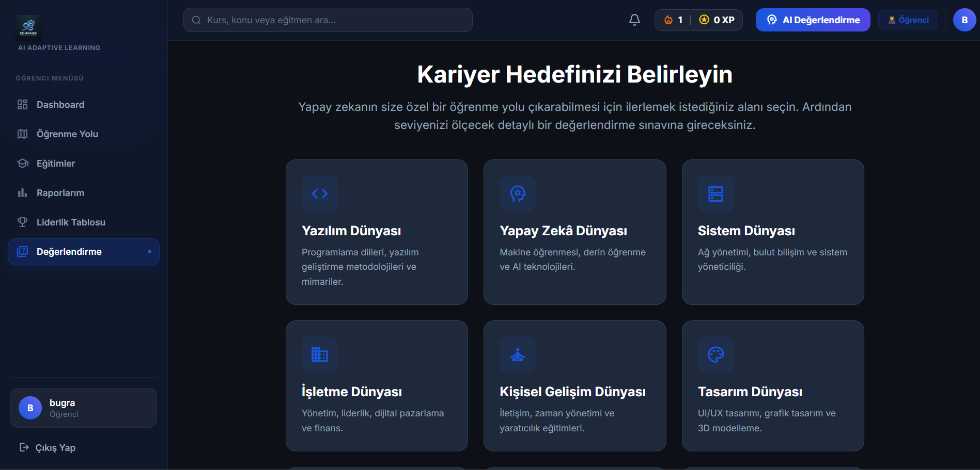
Most traditional e-learning systems operate using fixed content delivery structures. These systems generally lack intelligent mechanisms capable of:

* Identifying learner-specific knowledge gaps
* Dynamically adapting learning sequences
* Providing personalized recommendations
* Maintaining learner engagement
* Supporting collaborative educational interactions

Additionally, many educational systems fail to integrate modern AI technologies effectively into personalized learning workflows. Existing systems frequently rely on static recommendation mechanisms or simple rule-based adaptation models that cannot fully understand learner context and educational progression.
There is therefore a need for an intelligent adaptive learning system that combines:

* Personalized educational guidance
* Dynamic learning adaptation
* AI-powered recommendation systems
* Interactive learning mechanisms
* Social and gamified educational experiences
1.3. Project Objectives
The primary objectives of EduVise are:

* To develop a full-stack adaptive learning platform
* To implement AI-driven personalized learning recommendations
* To generate adaptive learning roadmaps dynamically
* To improve learner engagement through gamification
* To support collaborative learning through forums
* To provide AI-generated counseling and analytics
* To design scalable and maintainable software architecture
* To integrate Large Language Models into educational workflows
1.4. Significance of the Project
EduVise contributes to educational technology by combining modern software architecture with AI-powered adaptive learning methodologies. The project demonstrates the practical application of Large Language Models in intelligent educational systems and highlights the importance of personalization, engagement, and learner-centered educational design.
The system also provides a scalable architecture suitable for future expansion into larger educational ecosystems.

II. LITERATURE REVIEW
2.1. Traditional E-Learning Platforms
Traditional e-learning systems such as Moodle, Blackboard, Coursera, and edX have significantly improved educational accessibility. These platforms provide video lectures, quizzes, assignments, and content management tools for large-scale educational delivery.

However, most traditional platforms follow static educational structures. Learners are generally required to follow identical learning paths regardless of their educational background or performance level. This limitation reduces educational efficiency and personalization.
2.2. Adaptive Learning and Intelligent Tutoring Systems
Adaptive learning systems dynamically personalize educational content according to learner performance and knowledge states. Intelligent Tutoring Systems (ITS) represent one of the earliest forms of adaptive educational technology.
Systems such as ALEKS and Cognitive Tutor demonstrated that adaptive educational pathways could significantly improve learning efficiency and learner outcomes.
2.3. Artificial Intelligence in Education
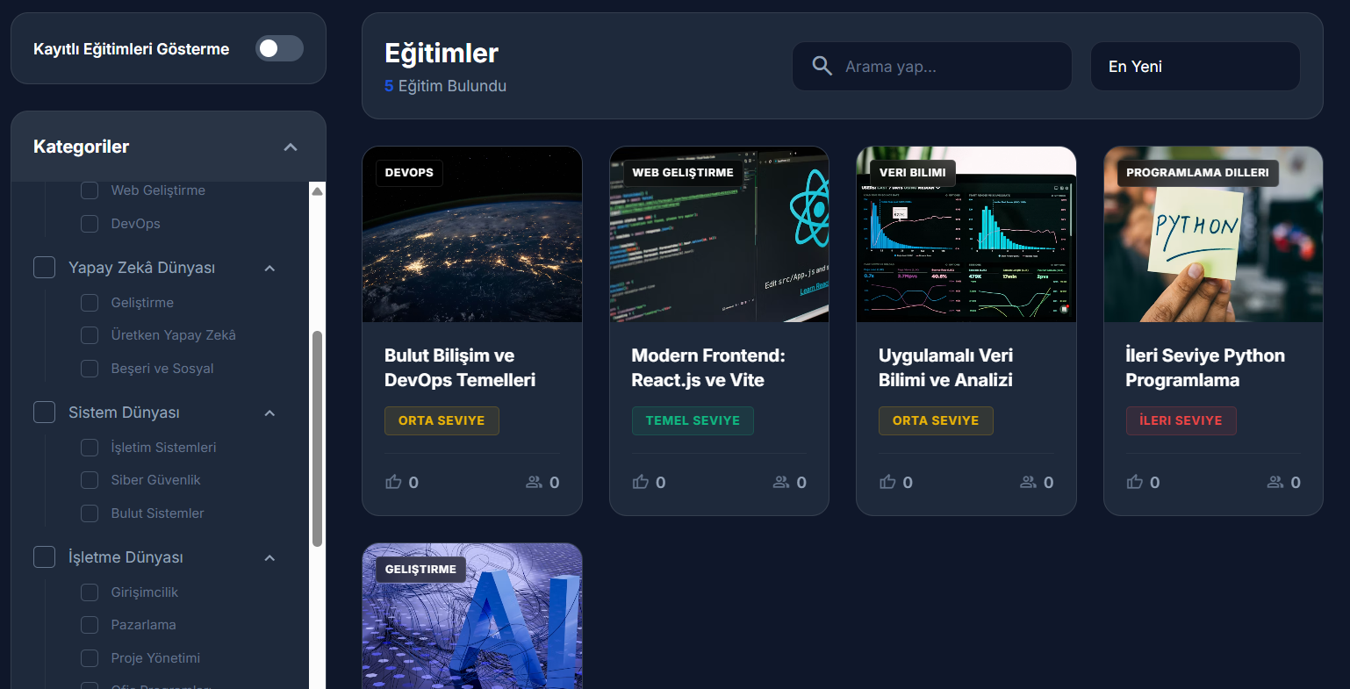
Artificial Intelligence in Education (AIEd) integrates machine learning, recommendation systems, educational data mining, and learner modeling into educational platforms.

AI technologies enable:
* Personalized recommendations
* Knowledge tracing
* Predictive analytics
* Intelligent tutoring
* Automated feedback generation

Modern AI systems significantly improve adaptive educational experiences compared to static systems.
2.4 Large Language Models in Education
Recent developments in Large Language Models have transformed AI-assisted educational systems. LLMs are capable of understanding natural language, generating contextual explanations, and producing adaptive educational recommendations.

Unlike traditional rule-based AI systems, LLMs provide:

* Context-aware educational guidance
* Personalized explanations
* Dynamic recommendation generation
* Conversational educational interaction

EduVise integrates Anthropic LLM services to provide advanced adaptive educational support.
2.5 Gamification and Interactive Learning
Gamification mechanisms improve educational engagement by introducing reward-based interaction systems into learning environments.

Educational gamification commonly includes:
* Experience points
* Achievement badges
* Leaderboards
* Daily challenges
* Learning streaks
Research demonstrates that gamification increases learner motivation and participation rates.

2.6 Research Gap and Contribution

Existing adaptive learning systems frequently lack:

* Modern LLM integration
* Interactive community systems
* Gamification infrastructure
* Scalable lightweight architectures
* Real-time personalized counseling

EduVise addresses these limitations through:

* LLM-powered adaptive recommendations
* Gamified educational interactions
* Community-based learning forums
* Real-time notification systems
* Modern full-stack architecture

III. METHODOLOGY
The selected methodology prioritizes modularity and adaptability due to the evolving nature of personalized learning systems. Knowledge graph modeling is chosen to explicitly represent prerequisite relationships between concepts, enabling explainable and structured learning path generation. A microservices architecture is adopted to support scalability and independent evolution of system components, particularly the AI engine, which may require frequent model updates.
3.1. System Architecture Overview
EduVise follows a modern client-server architecture composed of frontend, backend, AI integration, and database layers.
The system architecture includes:

* React frontend application
* FastAPI backend server
* Anthropic LLM integration
* SQLite database infrastructure
* RESTful API communication

The modular architecture improves scalability, maintainability, and future extensibility.

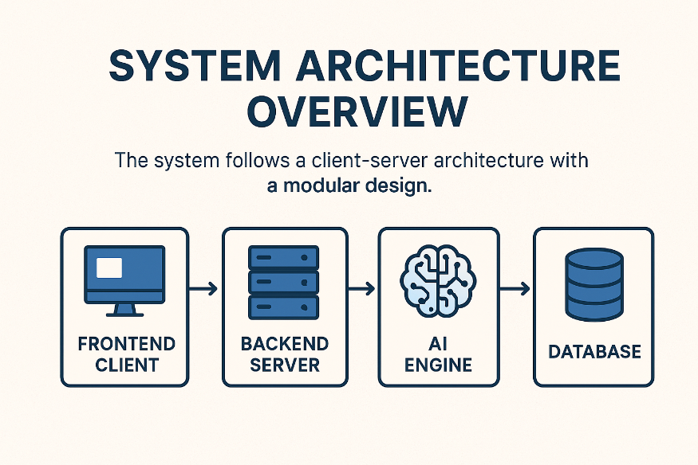

3.2 Course and Assessment Structure
Educational content is divided into modular learning units connected through prerequisite relationships.
Each module contains:
* Video lessons
* Learning materials
* Practice exercises
* Assessments
* AI-generated explanations
Assessments are mapped to educational concepts to enable adaptive recommendation generation.

3.3. Algorithm Development
The adaptive recommendation system analyzes learner performance and dynamically updates learning pathways.

The system performs:
* Diagnostic analysis
* Knowledge gap identification
* Roadmap generation
* Dynamic recommendation updates
* AI-generated counseling

3.4 AI Integration
The platform integrates Large Language Models through Anthropic API services.

The AI infrastructure supports:
* Personalized recommendations
* Educational guidance
* Dynamic explanations
* Counseling report generation
* Learning analytics interpretation
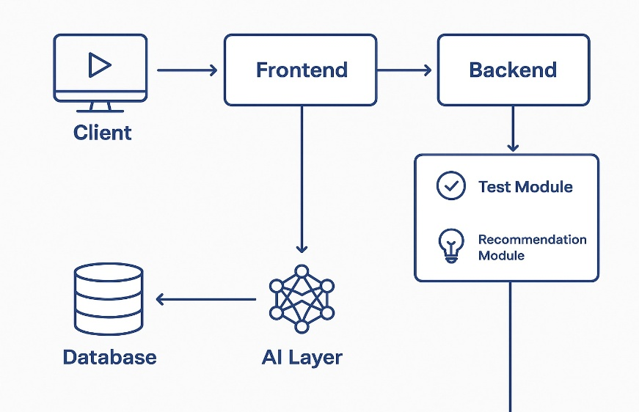

3.5 System Implementation
Frontend Technologies:
* React.js
* Vite
* Tailwind CSS
* Zustand

Backend Technologies:
* Python
* FastAPI
* SQLAlchemy

Database:
* SQLite

AI Infrastructure:
* Anthropic API

3.6 Advanced Modules
The system includes:
* Gamification infrastructure
* Forum system
* Notification system
* Payment management
* Real-time interaction support

3.7 Validation and Testing
Testing procedures included:
* Functional testing
* API testing
* Database testing
* Interface testing
* Performance evaluation
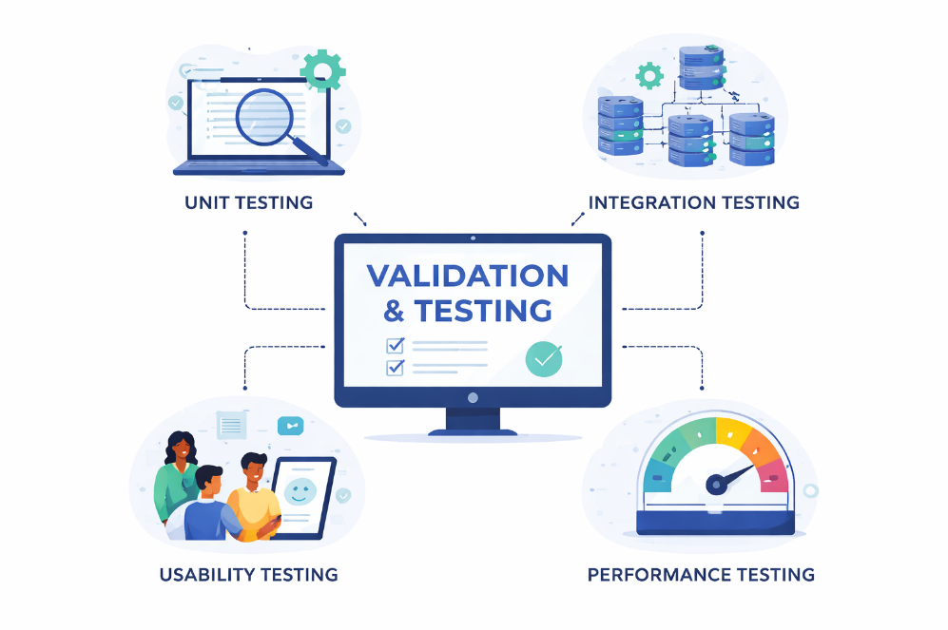

IV. SYSTEM DESIGN AND IMPLEMENTATION
4.1 Frontend Architecture
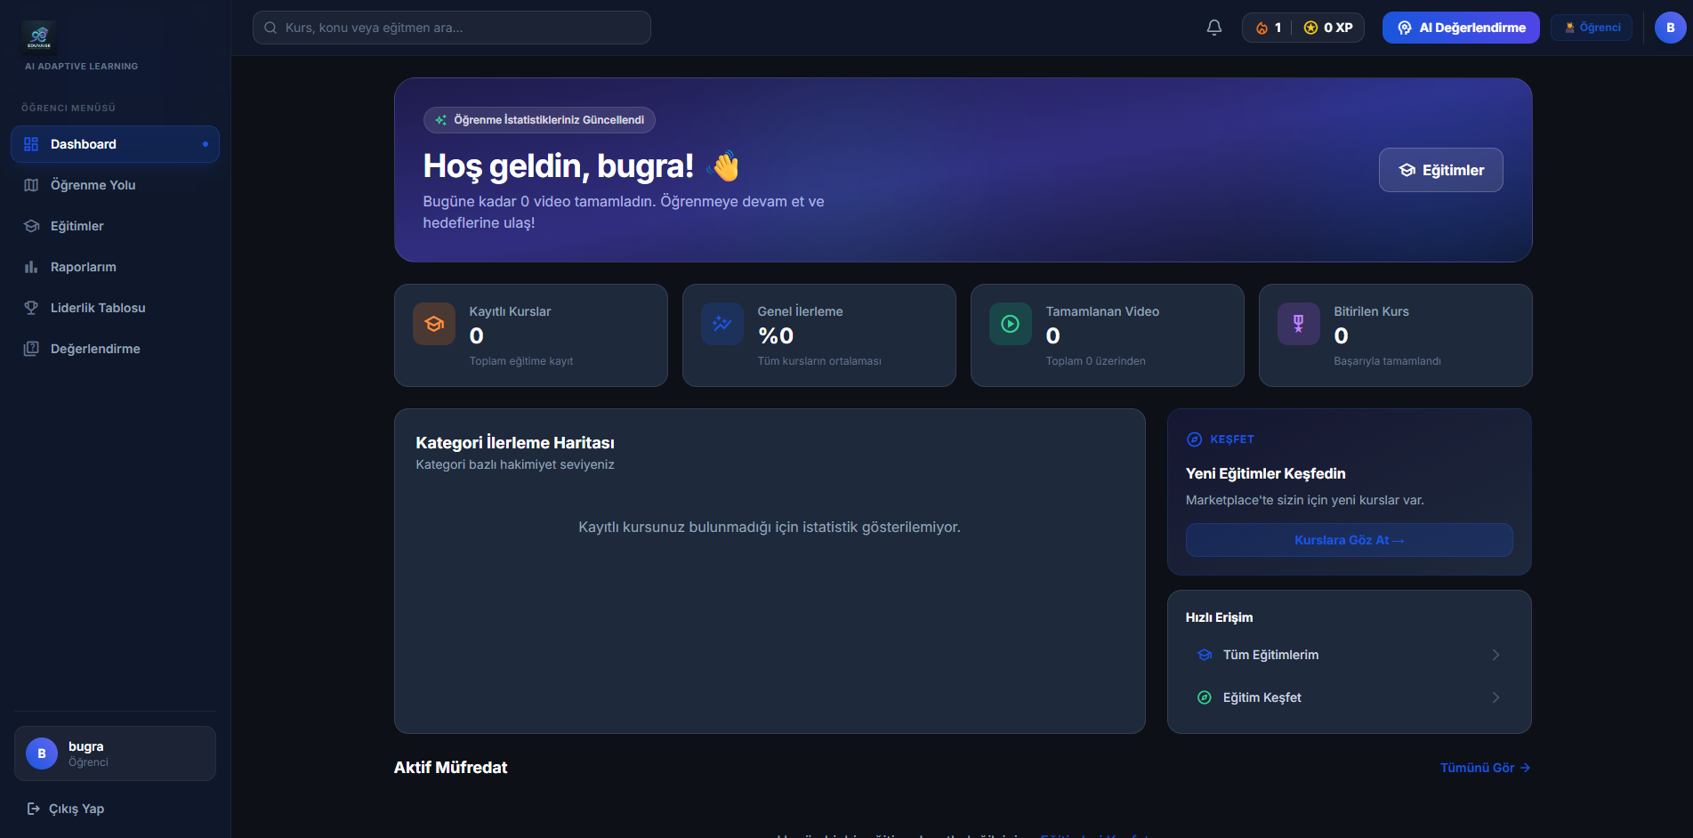
The frontend application was implemented using React.js and Vite.
Tailwind CSS was used for responsive interface design and Zustand was utilized for centralized state management.
The frontend includes:
* Student dashboards
* Adaptive roadmap visualization
* Gamification interfaces
* Community forums
* Notifications
4.2 Backend Architecture
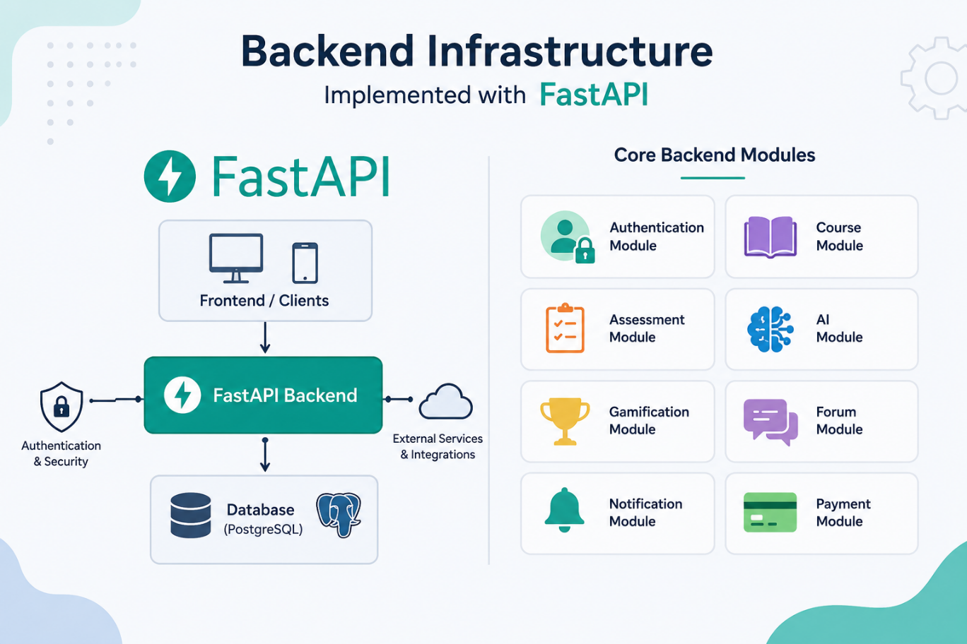
The backend infrastructure was implemented using FastAPI.
Core backend modules include:
- Authentication module
- Course module
- Assessment module
- AI module
- Gamification module
- Forum module
- Notification module
- Payment module
4.3 Database Design
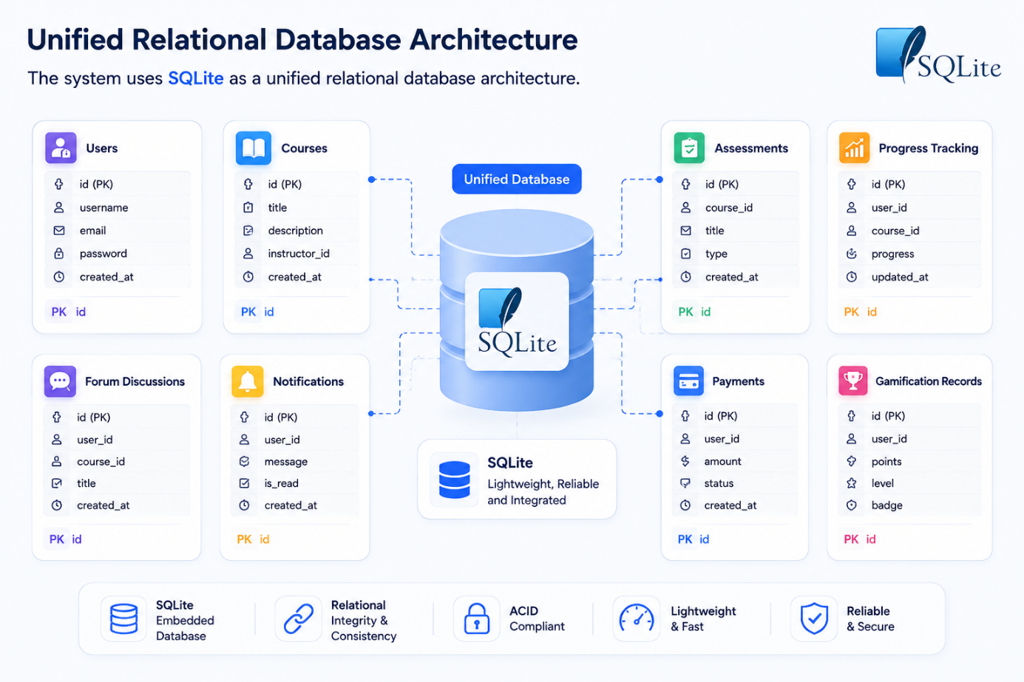
The system uses SQLite as a unified relational database architecture.
Primary database tables include:
- Users
- Courses
- Assessments
- Progress tracking
- Forum discussions
- Notifications
- Payments
- Gamification records

4.4 API Design
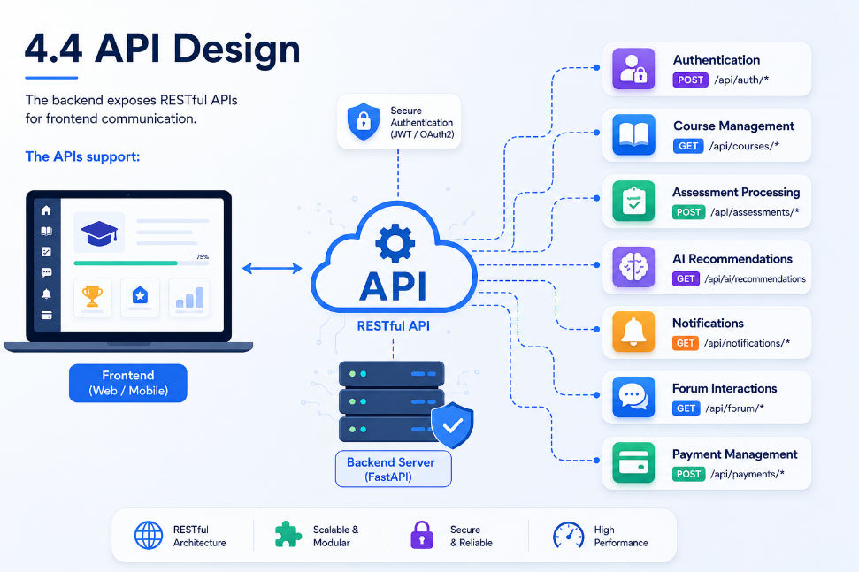
The backend exposes RESTful APIs for frontend communication.
The APIs support:
* Authentication
* Course management
* Assessment processing
* AI recommendations
* Notifications
* Forum interactions
* Payment management

4.5 AI Recommendation Infrastructure
The AI system integrates directly with Anthropic LLM services.

The AI engine generates:

* Personalized learning roadmaps
* Dynamic educational recommendations
* AI counseling reports
* Concept explanations

4.6 Gamification System
The gamification infrastructure supports:
* XP systems
* Achievement badges
* Leaderboards
* Learning streaks
* Daily missions

4.7 Forum Infrastructure
The forum system enables:

* Educational discussions
* Peer collaboration
* Question-answer interactions
* Community engagement

4.8 Notification System
The notification system provides:
* Real-time updates
* Reminder notifications
* Achievement alerts
* Course announcements

4.9 Payment System
The payment infrastructure manages:
* Premium subscriptions
* Course purchases
* Transaction history
* Payment authorization

V. RESULTS AND EVALUATION
This section presents the expected outcomes of the EduVise project and outlines the planned evaluation methodology. Since the current phase of the graduation project focuses on system design, algorithm development, and architectural planning, the platform has not yet been fully implemented or deployed. Therefore, the results discussed in this section are prospective and describe how the system is expected to perform once implementation and real-world testing are completed in the subsequent project phase.
5.1 System Outcomes
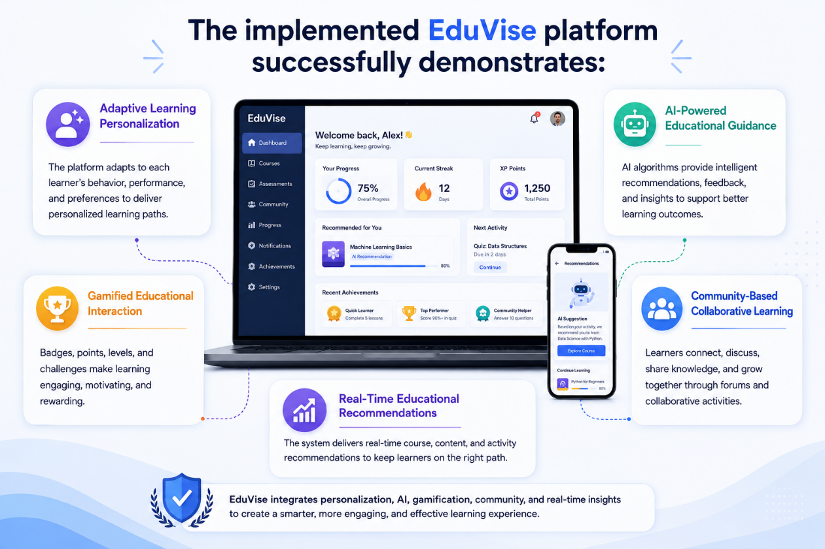

The implemented EduVise platform successfully demonstrates:

* Adaptive learning personalization

* AI-powered educational guidance

* Gamified educational interaction

* Community-based collaborative learning

* Real-time educational recommendations

5.2 Performance Evaluation
Performance testing demonstrated stable backend response times and reliable frontend rendering performance under expected project-level user loads.
5.3 User Experience Evaluation

The user interface successfully provided:

* Responsive navigation

* Clear educational workflows

* Interactive engagement

* Personalized educational experiences
5.4 Limitations
Current limitations include:
* Limited dataset size
* Absence of large-scale user testing
* Limited cloud deployment infrastructure
Future development phases aim to address these limitations.
VI. CONCLUSION AND FUTURE WORK
6.1. Conclusion
EduVise successfully demonstrates the integration of adaptive learning methodologies, modern full-stack software architecture, and Large Language Model technologies into a unified intelligent educational platform.
The project evolved beyond the originally planned architecture and was implemented using practical modern technologies including FastAPI, React.js, SQLite, Tailwind CSS, Zustand, and Anthropic LLM services.
The system demonstrates that AI-driven educational personalization can significantly improve learner engagement, educational efficiency, and adaptive learning experiences.

6.2. Future Work
Potential future improvements include:
* Mobile application support
* Cloud-native deployment
* Multi-language educational support
* Voice-based AI tutoring
* Reinforcement learning integration
* Advanced analytics dashboards
* Real-time collaborative classrooms
* AI-generated interactive exercises

VII. REFERENCES
1. Anderson, J. R., Corbett, A. T., Koedinger, K. R., & Pelletier, R. Cognitive Tutors: Lessons Learned.
2. Baker, R. S., & Inventado, P. Educational Data Mining and Learning Analytics.
3. Brusilovsky, P. Adaptive Hypermedia for Education and Training.
4. Corbett, A. T., & Anderson, J. Knowledge Tracing.
5. Doignon, J. P., & Falmagne, J. Spaces for the Assessment of Knowledge.
6. Graesser, A. C. AutoTutor: A Tutor with Dialogue in Natural Language.
7. Piech, C. Deep Knowledge Tracing.
8. Shute, V. Adaptive Educational Systems.
9. Siemens, G., & Baker, R. Learning Analytics and Educational Data Mining.
10. Tang, T., & McCalla, G. Smart Recommendation Systems for E-Learning.
APPENDICES
Appendix A: Sample Code Snippets
* POST /auth/login
* POST /auth/register
* GET /courses
* POST /assessment/submit
* GET /roadmap/generate
* GET /notifications
* POST /forum/create
Appendix B: Frontend Components
* Dashboard.jsx
* CoursePage.jsx
* AssessmentPage.jsx
* NotificationPanel.jsx
* Leaderboard.jsx
* ForumPage.jsx

Appendix C – AI Workflow
1. Diagnostic Assessment
2. Knowledge Gap Detection
3. Personalized Roadmap Generation
4. Dynamic Recommendation Updates
5. AI Counseling Generation

